PWM Methods

Abstract
This document introduces several PWM generation methods:
- Modulation Schemes
- Reference Signal
- Sampling
- SVPWM

Modulation Schemes

Intersection method
The switching state is determined by the intersections of the reference signal and the carrier signal: When the reference signal is larger than the carrier signal, the upper switch is turned on and the lower switch is off; otherwise, the upper switch is off and the lower switch is on.

Delta method
The actual phase current i_{A} is compared with the tolerance band around the reference current
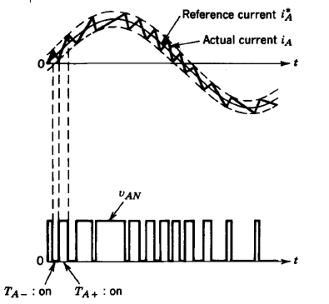

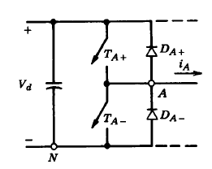

If the actual current tries to go beyond the upper tolerance band, TA- is turned on. If go below, the lower tolerance band, TA+ is turned on

Reference signal

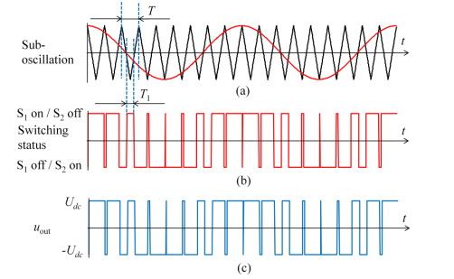
Sinusoidal PWM (SPWM)

Sinusoidal PWM (SPWM) is a most widely used PWM generation method. A triangular signal called carrier signal is compared with a sinusoidal reference signal. If the frequency of the carrier signal is much higher than that of the reference signal, the low frequency components of the PWM output can be very close to the waveform of the reference signal.

Third-harmonic PWM
Third harmonic PWM method makes better use of the DC bus voltage.
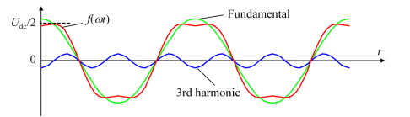

Instead of using a pure sinusoidal wave, the reference signal is now superimposed by its third harmonics. This reference signal is then compared to a carrier signal the same way as the SPWM method.
The third harmonics component is undesirable but is naturally filtered out in three-phase motor windings. Therefore, only the fundamental signal remains and the modulation index is higher.

Sampling

Natural Sampling
Natural sampling controls the conducting state of the switches in such manners: When the reference signal is larger than the triangle signal, the upper switch is turned on and the lower switch is off; otherwise, the upper switch is off and the lower switch is on.
The advantage of natural sampling is that the output is very close to sinusoidal. However, the intersection of reference signal and triangle signal cannot be solved without using numerical method, which consumes a significant amount of computation time and renders the control of PWM generation challenging.

Regular Sampling
Instead of directly using natural reference signal, regular sampling samples the reference signal periodically. Until next sample is taken, the current sample is used to determine the switching states: when the sample signal is larger than the triangle signal, the upper switch is turned on and the lower switch is off; otherwise, the upper switch is off and the lower switch is on.
The computation of regular sampling is simpler as it does not need to solve transcendental equations. Hence, it can be utilized in real-time control of PWM generation. The disadvantage is that the modulation index is lower than natural sampling.

SVPWM (Space vector PWM)
Because both switches in the same leg cannot be on at the same time, there are eight possible switching vectors for an inverter.
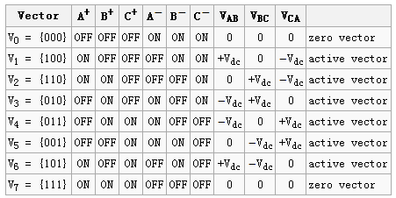

The sampled reference signal can be represented by two adjacent active switching vectors and one or two of the zero vectors. The factors of the combination can be determined by various algorithms, some of which are able to reduce THDs but may cause other problems.

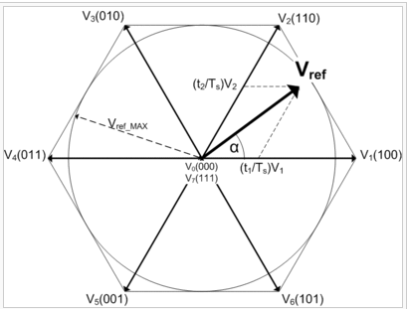

Reference
[1] R. Kennel, Power Electronics Exercise: Pulse Width Modulation Methods, Technische Universität München, 2012

